Campaigner training stats across all three sessions

Average scores for each question across all three sessions
Session | Skills development | Confidence development | Teacher rating | Topic relevance | Resource rating | Overall rating
1 | 8.4 | 8.8 | NA | NA | NA | NA
2 | 8.2 | 7.5 | 8.6 | 8.7 | 8.1 | 8.2
3 | 9.1 | 9.1 | 9.7 | 9.5 | 9.6 | 9.8

I can present these in graphical form as well.
You can see a clear increase in rating in all six categories between the first and third session – good for messaging about how the course has developed.

Overall, how would you rate this course? On a scale of 1 (Poor) to 10 (Excellent)
Note: this question was not in the first survey
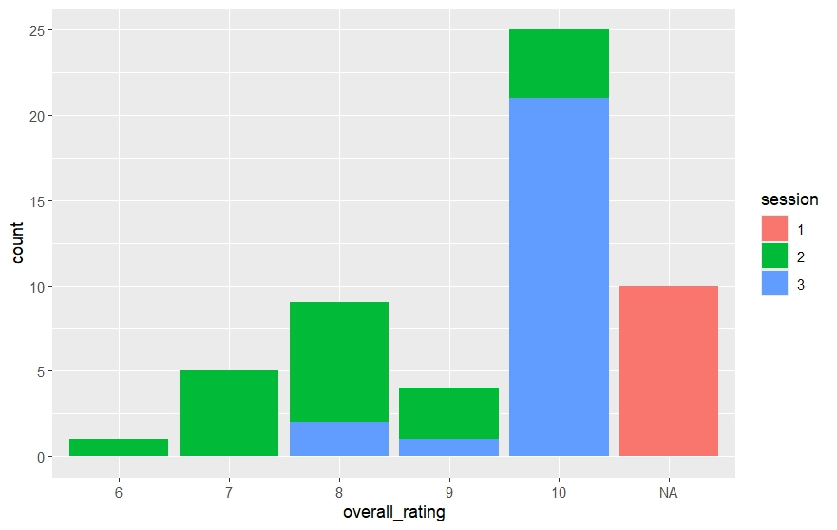

Please tell us how you found the teaching and facilitators on this course
Note: this question used a different scale in the first survey so is presented separately for that session
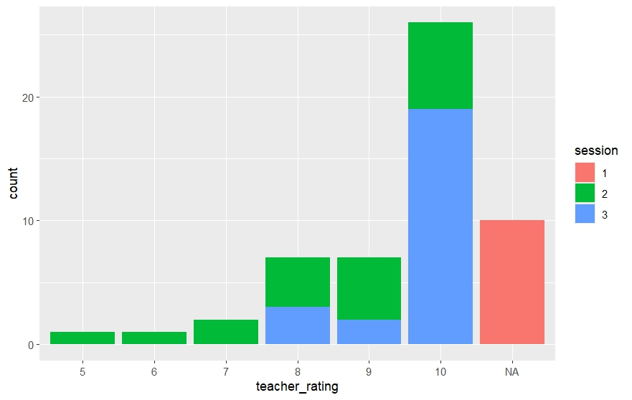

How useful were the resources on this course? (Consider the slides, problem-based learning activities, use of Moodle, additional readings, discussion reflection threads, break out rooms, etc.)
Note: this question used a different scale in the first survey so is presented separately for that session
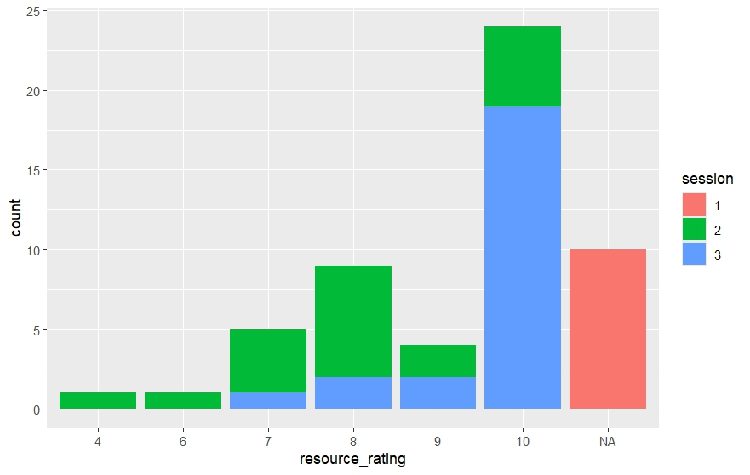

How relevant were the topics covered in this course to develop you as a campaigner? On a scale of 1 (not relevant at all) to 10 (highly relevant)
Note: this question used a different scale in the first survey so is presented separately for that session
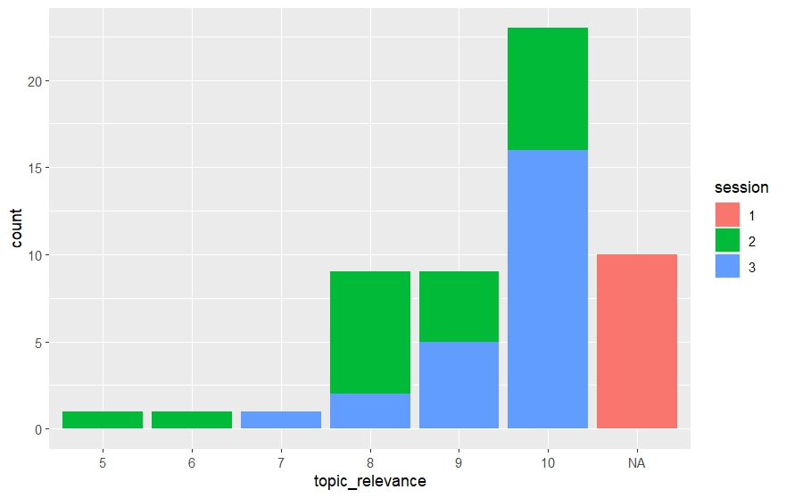

To what extent have your skills as a campaigner improved as a result of completing this course. On a scale of 1 (not improved) to 5 (improved significantly)
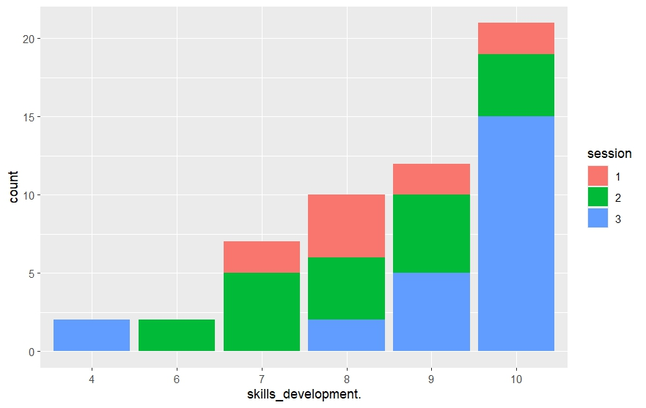

To what extent has your confidence as a campaigner improved as a result of completing this course? On a scale of 1 (not improved) to 5 (improved significantly)
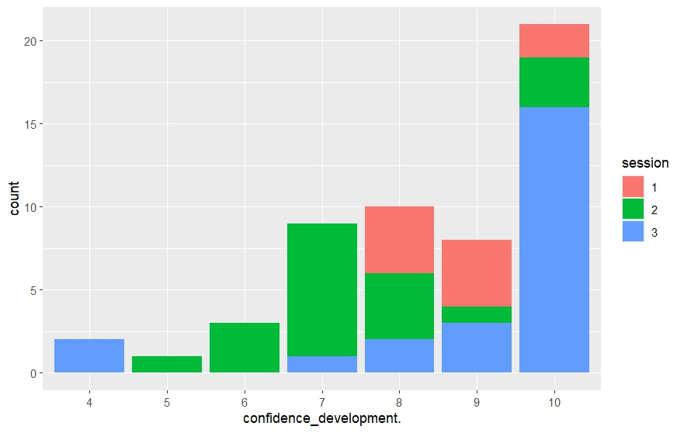

Campaigner training 1

Overall, how would you rate the quality of the teachers and trainers on this course?
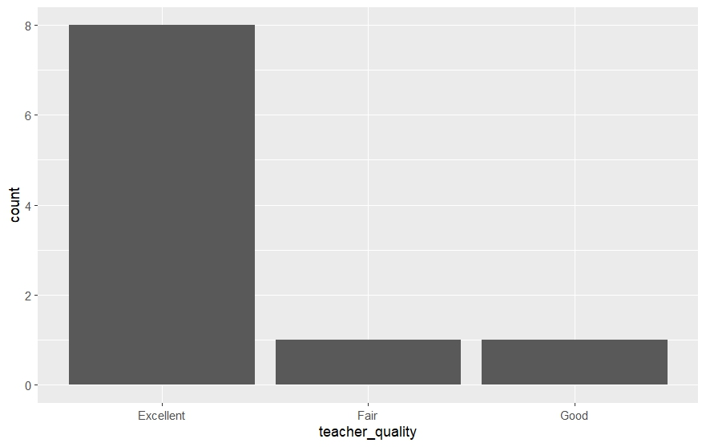

Overall, how would you rate the relevance of the topics covered throughout this course?
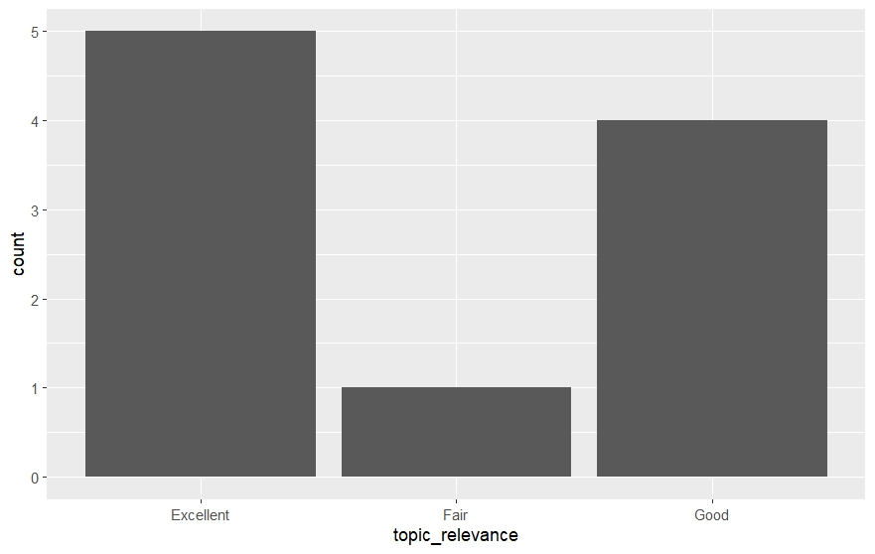

Overall, how would you rate the quality of the resources on this course? (For example, Moodle, additional readings, Problem Based Learning activities, etc.)
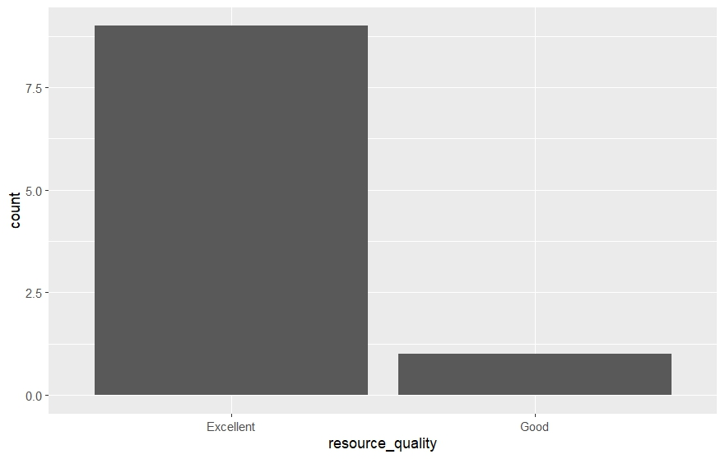

Overall, how well-organised was this course?
